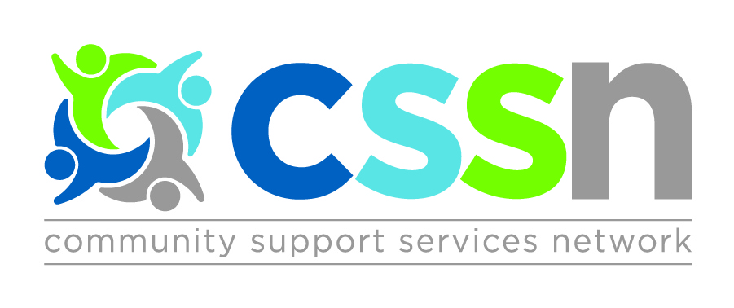

Positioning the Central CSS Sector for the Future

Thursday April 19th, 2018
8:30am – 12:00pm

Guest Speakers:
- Chantell Tunney & Carol Edward, Central LHIN
- Patrick Boily, OCSA

Facilitated by Sue Lantz

Questions to be answered:
- What is the vision of the LHIN/Ministry for the CSS Sector?
- What opportunities exist for the sector to contribute and meet the needs of the population?
- How can the CSS Sector better articulate its incredible value to the health system?

Target Audience:
- Senior Leaders of all CSS Network Member Agencies

Agenda
8:30am: Registration & Continental Breakfast
9:00am – 10:00pm: Presentations
10:00am – 12:00pm: Workgroups

***Location (note change)***
Newmarket Health Centre
194 Eagle St. Newmarket

Members: Register online at http://cssnetwork.ca/event/april192018/

Registration Deadline: Friday April 6th, 2018

