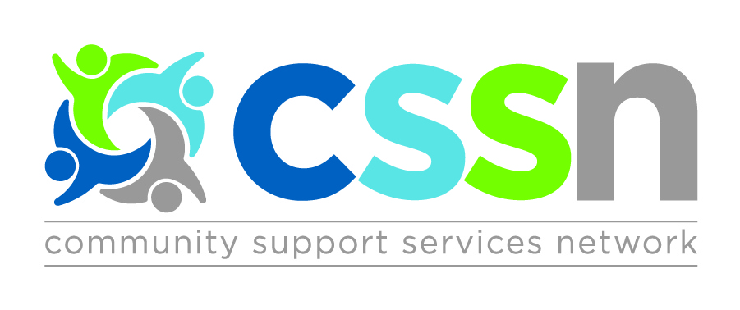

The Central Community Support Services Network (CSSN) presents

Network Education Session:
Bill 148 – Fair Workplaces, Better Jobs Act 2017

Facilitator: Thomas Gorsky
Sherrard Kuzz LLP

Topics:
- Overview of legislative changes
- What we need to do to ensure compliance
- Q&A

Target Audience:
- Senior Leaders
- HR Leaders

Wednesday February 28th, 2018

8:30am: Registration & Continental Breakfast
9:00am – 12:00pm: Education Session

Location:
YSSN Training Room
240 Edward St Unit 3 Aurora, ON L4G 3S9

Cost:
Members: FREE (2 people per agency)

Members: Register online at http://cssnetwork.ca/event/education-session-bill148/

Registration Deadline: Thursday February 15th, 2018

