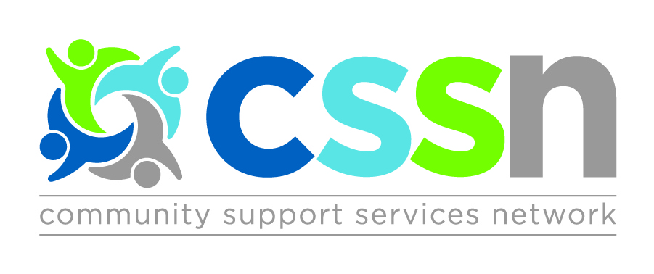

The Central Community Support Services Network (CSSN) presents

Quality Education Session:
Focus on Measurement

Facilitator: Paula Blackstein-Hirsch

Topics:
- Types of Measures for Accountability, Improvement & Research
- Critique of Measures in Quality Improvement Plans (QIPs)
- Outcome and Output Measures
- Sustaining Change

Wednesday November 1st, 2017

8:30am: Registration & Continental Breakfast
9:00am – 3:30pm: Education Session (Lunch Included)

Cost:
Members: FREE (2 people per agency)
Non-Members: $25 per person

Location:
Newmarket Community Centre – Lions Hall #2
200 Doug Duncan Drive Newmarket, ON L3Y 3Y9

Members: Register online at http://cssnetwork.ca/event/education-session-nov-2017/
Non-Members: email nimisha.hirji@cssnetwork.ca

Registration Deadline: Thursday October 12th, 2017

