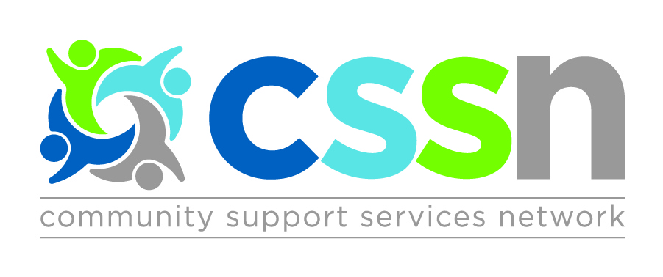

Central CSS Network Meeting

Friday October 4th, 2019

9:00am – Breakfast & Registration
9:30am – 12:00pm – Meeting

Earl Bales Community Centre
Meeting Room 3 (C)
4169 Bathurst St
Toronto, ON M3H 3P7

AGENDA
- Ontario Health Team (OHT) Updates
  - Current status
  - Updates from team members
  - Key Issues surrounding OHTs
- Guest Presentation: Woodgreen
- Steering Committee Elections

Please RSVP by Tuesday October 1st, 2019
http://cssnetwork.ca/event/network-meeting-oct2019/

