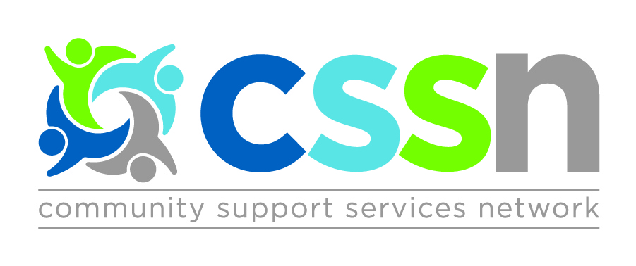

Central CSS Network Meeting

Wednesday September 26th, 2018

9:30am – Breakfast & Registration
10:00am – 12:30pm – Meeting

Newmarket Health Centre
194 Eagle St
Newmarket, ON L3Y 1J6

AGENDA
- Sub-Region Planning Group Updates
- Caregiver Support Framework
(Presented by Sue Lantz & Loren Freid)
- HR Alliance Update
- Visual Map (from April 19th Strategy Session)
- Steering Committee Elections

Please RSVP by Friday September 21st, 2018
http://cssnetwork.ca/event/network-meeting-sept-2018/

